The solutions of x⁶ = x³ using Phantom Graphs
---------------------------------------------------------------------------

Most people just put x⁶ – x³ = 0
x³(x³ – 1) = 0
x = 0 or 1
Some of the better people carried on and put if x³ = 1 let x = r cis(θ)
So that r³cis(3θ) = 1cis(360n) by using De Moivre’s Theorem
This means r = 1 and 3θ = 360n so θ = 120n = 0°, 120°, 240°
(actually most people use radians but I work better in degrees)
The solutions are: $x_{1}=1 cis\left(0\right) =$1
$x_{2}=1 cis\left(120\right)=\frac{-1}{2}+\frac{i\sqrt{3}}{2}$
$x_{3}=1 cis\left(240\right)=\frac{-1}{2}-\frac{i\sqrt{3}}{2}$
(– 0.5+0.866i, 1)
So my special contribution was to draw the graphs y = x⁶ and y = x³ with their phantoms which shows all the solutions clearly.

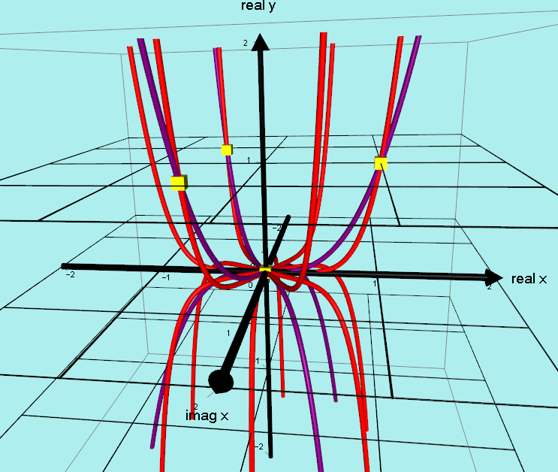
(– 0.5– 0.866i, 1)
(1 + 0i, 1)
Incidentally, because of the Fundamental Theorem of Algebra there are 3 more solutions at the origin. The graphs actually cross 3 more times there.

